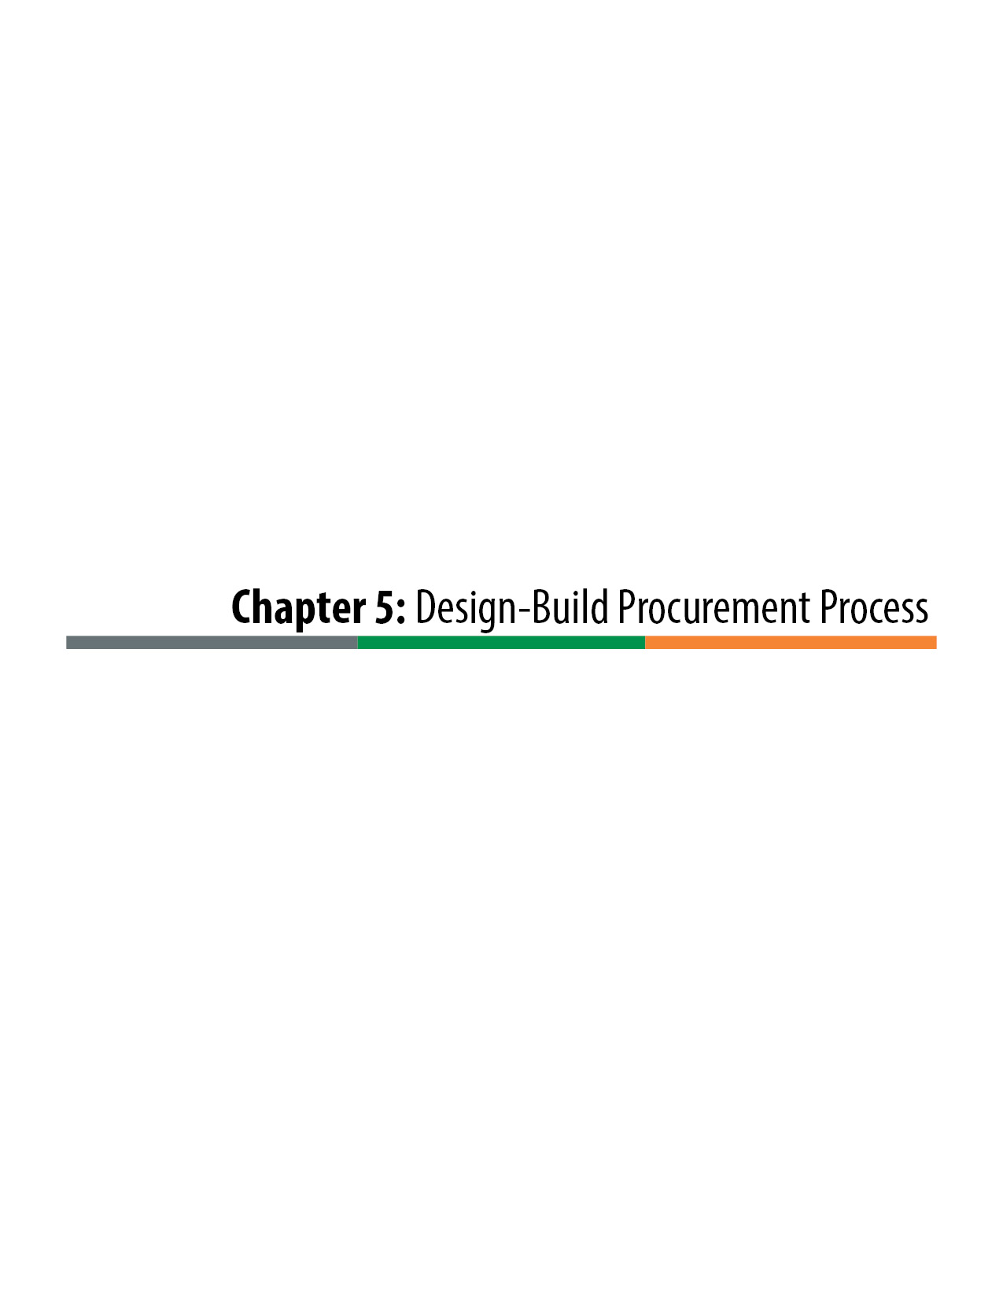

-Design-Build Procurement Process
The Design-Build procurement process is one of most important phases of Design-Build delivery. It is important to recognize that the procurement phase is much more than selection of the Design-Builder for the project. It is a pivotal step in the design development of the project. It implements a collaborative process between the owner and the Design-Builder to advance the design of the project in a manner that both maximizes the project goals and provides the most cost-efficient designs to achieve those goals. During this phase, the owner advances the project by continued development of the Basic Configuration, the Reference Drawings, and the RFP Documents that guide the design of the project, and the Design-Builder develops a detailed Proposal that further advances the project design development. Together, the owner and Design-Builder collaborate on a refined design and a Proposal that reflects the values of the owner through a series of industry review meetings and confidential one-on-one meetings. These processes, unique to Design-Build, are key elements in recognizing the advantages that Design-Build delivery can offer in providing the most efficient and timely project.
The primary steps of the Design-Build procurement process are:
Issue a Request for Letters of Interest (LOIs): Notify the industry of the upcoming procurement and define the field of Design-Builders that are interested in pursuing the project.
Issue a Request for Qualifications (RFQ): Solicit statements of qualifications and provide the industry with the basic definition of the project.
Receive and Evaluate Statements of Qualifications (SOQs): Determine the firms that can best meet the project goals and create the short list of firms to invite to participate in the Proposal process.
Issue a Draft Request for Proposals (Draft RFP): Provide proposers with a detailed near-final RFP to review and evaluate.
Conduct Industry Review Meetings: Solicit input from the industry on the Draft RFP to facilitate improvements to the RFP in response to industry concerns.
Issue a Final RFP: Provide proposers with final procurement and selection processes and final Contract Documents that govern the design and construction of the project.
Conduct Confidential One-on-One Meetings: Collaborate with potential Design-Builders to refine the design through development of proprietary Alternative Technical Concepts (ATCs), or allow them to modify the Basic Configuration with proposed Alternative Configuration Concepts (ACCs).
Requests for Clarification (RFC) and Addendums: Provide additional clarifications of the RFP Documents and make modifications to the RFP by issuing addendums.
Receive and Evaluate Proposals: Select the Design-Builder for the project.
The procurement process is illustrated in Figure 5-1 and detailed further in Figure 5-2.

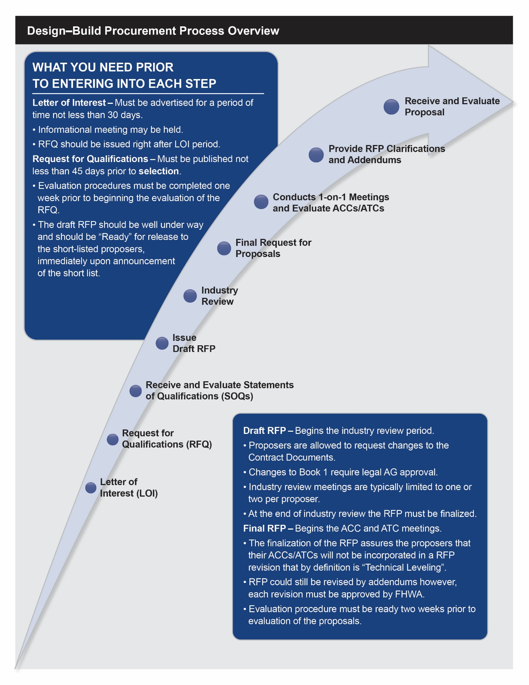
Figure 5-1. Design-Build Procurement Process Overview
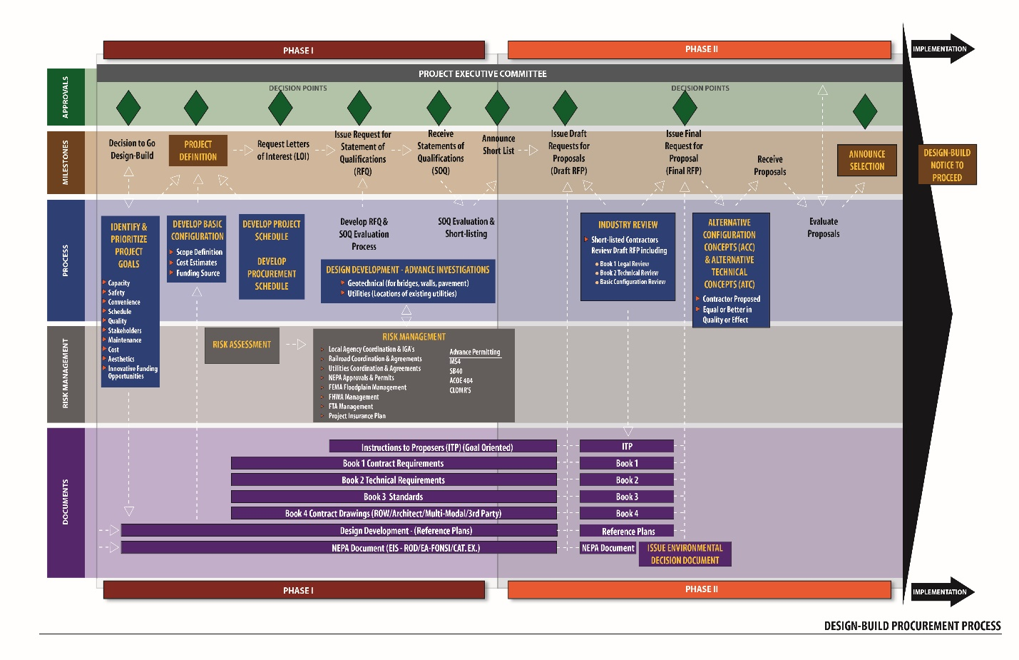
Figure 5-2. The Two-Phase Design-Build Procurement Process

The process as outlined is a two-phase selection procedure in that it involves an SOQ and short-listing phase before the Proposal phase. This process should be followed for most Design-Build projects of significant size and complexity. The Colorado Department of Transportation (CDOT) also allows a Streamlined Design-Build (SDB) process that does not include the short-listing phase but instead goes directly to the Proposal phase of the project. SDB is most appropriately used for small projects of moderate complexity with well-defined scopes. In those cases, SDB can provide significant benefits by shortening and simplifying procurement processes.
The procurement steps represent the process of selecting the Design-Builder. But the procurement phase includes many activities beyond just the procurement process. All of the activities of the procurement phase are shown in Figure 5-2. As can be seen from the diagram, an extensive work effort is necessary to support the procurement process and to simultaneously advance the project development.
A typical procurement project schedule is provided in Figure 5-3. The Microsoft Project source file for the schedule template can be found online on the CDOT Innovative Contracting web page at:
https://www.codot.gov/business/designsupport/innovative-contracting-and-design-build.
The example schedule identifies approximately a one-year timeline for the procurement process, which is generally appropriate for Design-Build projects that are $50 million or more in construction value. Though Design-Build delivery offers a strong potential to minimize the overall delivery time, it does require a significant duration for the procurement phase to recognize its benefits. Both the owner and the Design-Builder advance the project development in the procurement phase. In particular, the Design-Builders will expend about 10 percent to 15 percent of their total design effort in their Proposal designs, if time allows, which greatly benefits the project as a whole.

Request for Letters of Interest
As is customary with developing, advertising, and awarding work, CDOT publically communicates its intent to procure the Design-Build project. This communication effort informs industry partners of CDOT’s intent to solicit industry Proposals, and it establishes a process and opportunity for CDOT and industry partners to begin to exchange information, gain understanding, and measure interest. CDOT’s initial release of information is prepared in a formal notice to the industry as a request for LOIs. For Design-Build projects this request is advertised by being published for a period of not less than 30 days in a newspaper of wide circulation, such as the in the Construction Daily Journal, weekly throughout the 30-day period. To economize the effort, the advertised notice is brief and refers to the detailed request for LOIs, which is made available online.
An example of a request for LOIs is shown in Figure 5-4, and a source file template request for LOIs is available in the online Appendix of this manual on the CDOT Innovative Contracting web page or by contacting CDOT Innovative Contracting. The request for LOIs shall be prepared on official CDOT letterhead paper and, at a minimum, should include the following information:
- a brief description of the project,
- the approximate construction value,
- the project goals,
- the schedule for the procurement process,
- CDOT’s anticipated date to issue the RFQ, and
- the specified cut-off date by which interested firms must submit Statements of Interest (SOIs).
An informational meeting may be conducted by CDOT to provide an opportunity for firms to ask questions and for CDOT to clarify project information and the procurement process. If the project team intends to hold an informational meeting, then the date, time, and place of the meeting should be included in the request for LOIs.
LOIs can be mandatory or optional, to be determined on a project basis. Mandatory LOIs can provide the project team with a better understanding of the industry interest in the project, but they can also be misleading when they include responses from Contractors that may not be likely to pursue the project.
Authorization of the letter content and approval to release should be obtained from the Executive Oversight Committee (EOC).

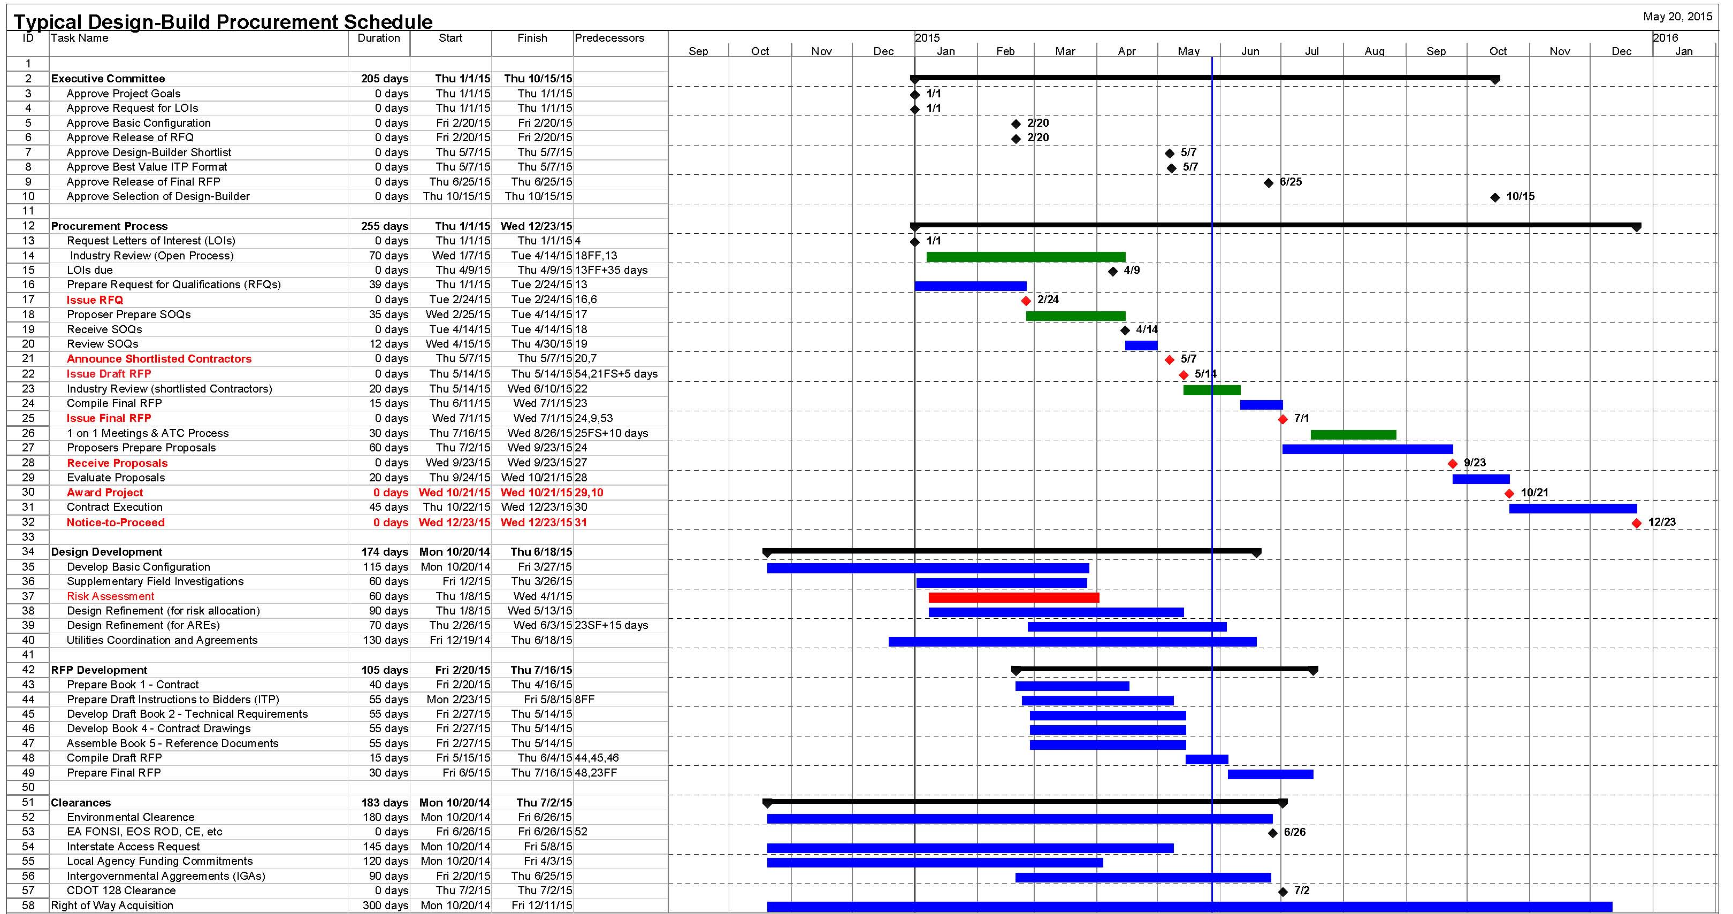
Figure 5-3. Typical Design-Build Procurement Schedule
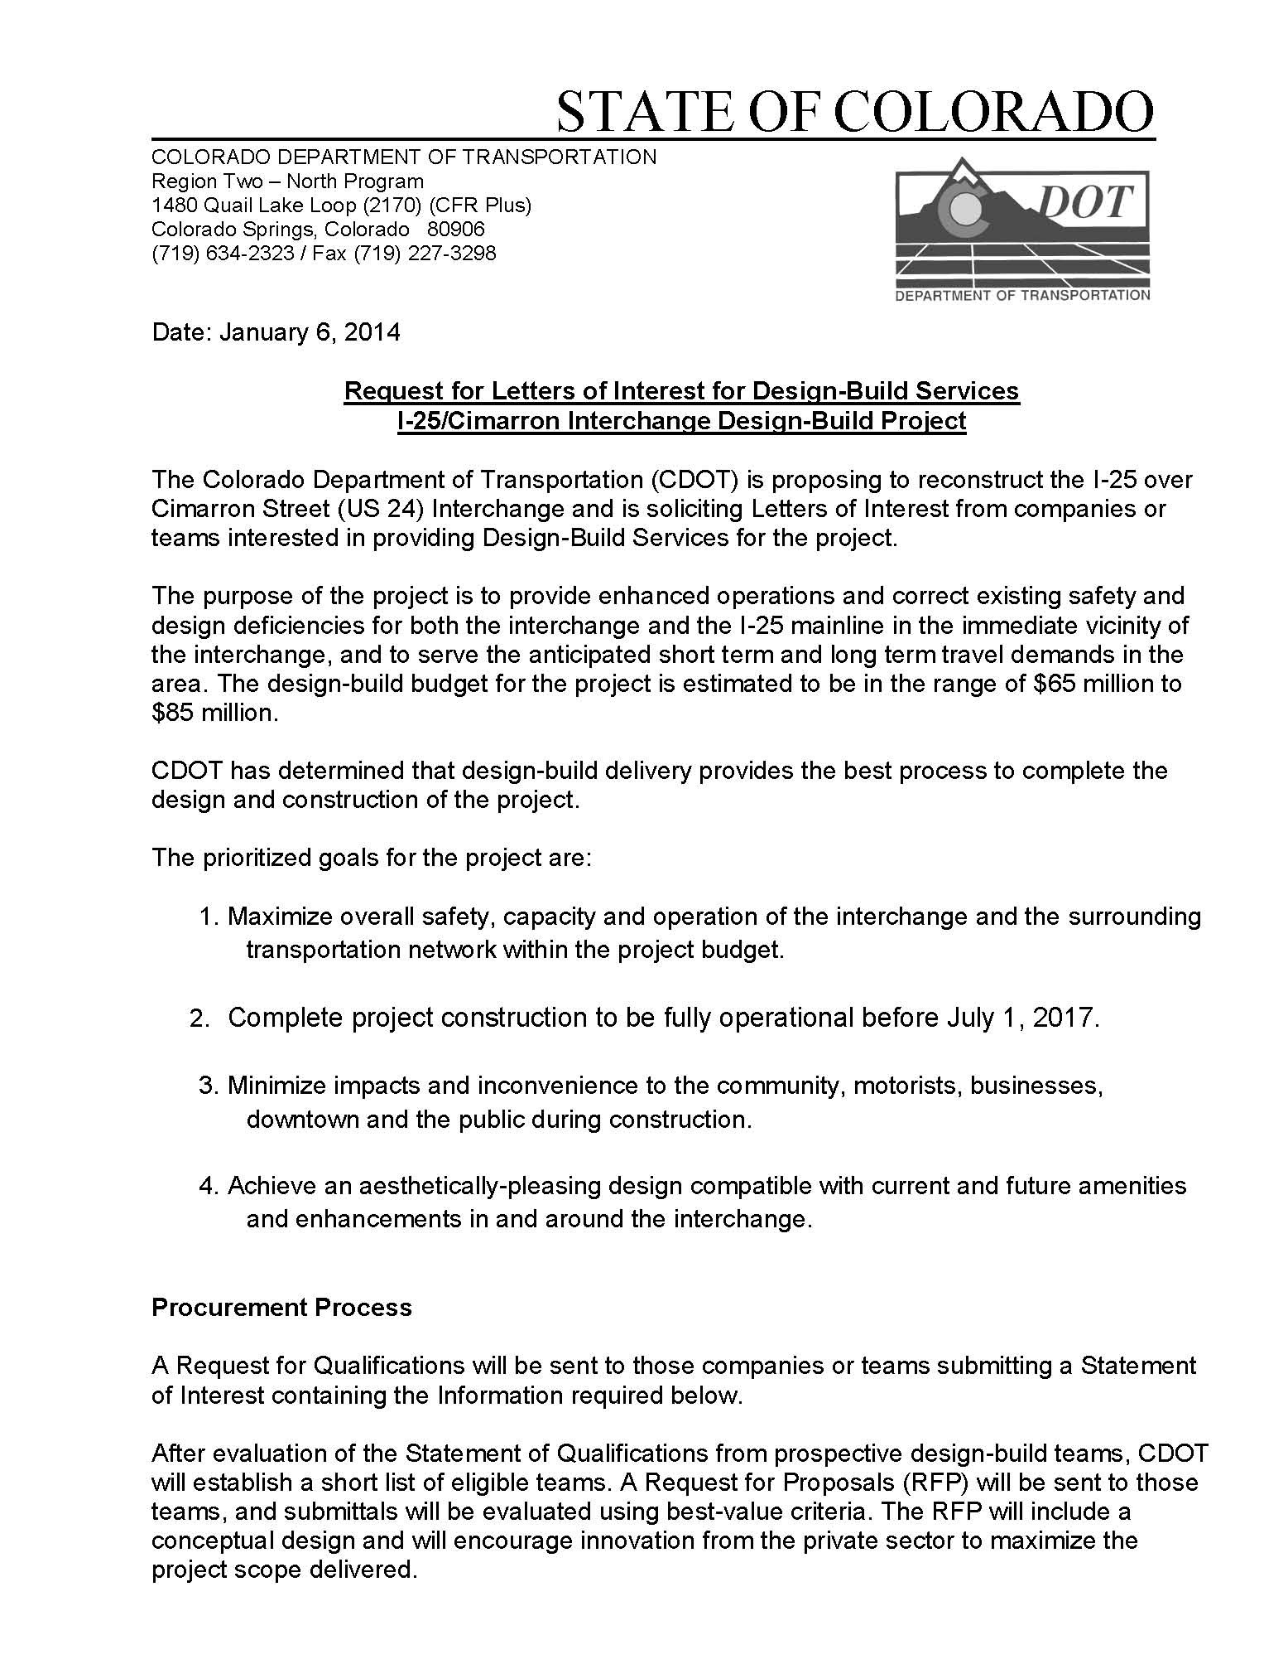
Figure 5-4. Example Request for Letters of Interest (LOIs)
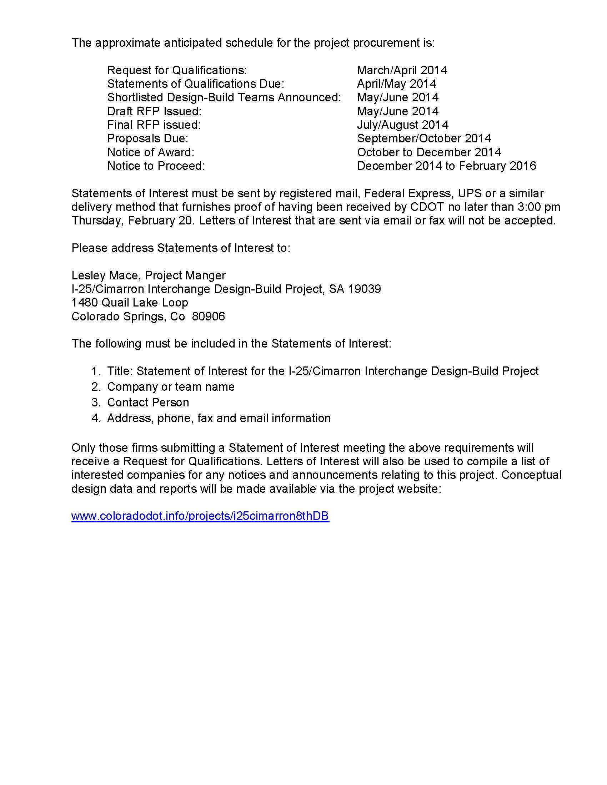
Figure 5-4. (continued)

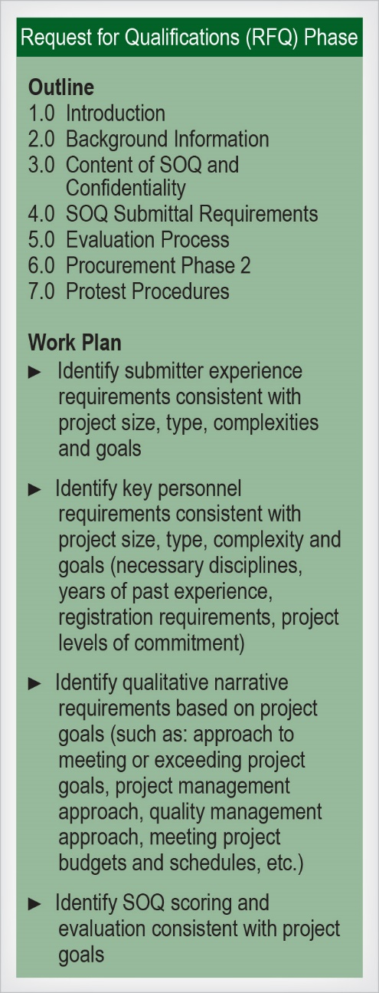
Phase 1—Request for Qualifications, Statements of Qualifications, and Short-Listing

The RFQ process is the first phase of the two-phase procurement process for Design-Build delivery. It is a formal and structured process that must comply with federal regulations, state statutes, and the Code of Colorado Regulations (refer to Chapter 1 in this manual for a discussion of the Design-Build regulations). The RFQ asks interested submitters to provide an SOQ in response to criteria defined within the RFQ. The RFQ should not be issued until the completion of the 30-day minimum duration allowed for LOIs, and the RFQ should be published at least 45 days prior to the SOQ submittal date.
SOQ submitters should be offered opportunities for one-on-one meetings with CDOT after the release of the RFQ. One-on-one meetings can be very valuable to the submitters for clarifying the project goals and needs to be addressed in the CDOT project. The meetings are most valuable when the CDOT project team freely interacts with the submitters, as opposed to following a rigid outline of predetermined acceptable information to release. The meeting should start with a briefing from CDOT that is consistent across all meetings. Care should be taken to ensure that contradictory information is not provided. These meetings are not confidential as the RFQ is still under development, therefore the sharing of proprietary information from potential submitters should be discouraged during this phase of the procurement. Meeting notes should be taken by the CDOT project team to document the discussions, but as the meetings are informal and the information provided is nonbinding, the meeting notes should not be issued to the submitters.
Figure 5-5. RFQ Elements
The key elements of the RFQ and the work plan that the project team needs to perform to develop the RFQ are summarized in Figure 5-5 above. A typical RFQ and the word source file RFQ template are available in the online Appendix on the CDOT Innovative Contracting web page or by contacting CDOT Innovative Contracting.

Development and Structure of the Request for Qualifications
RFQ development is an important part of the procurement phase process. A well-thought-out, well-written RFQ facilitates a short-list determination that is based on how well the Design-Build team can meet the goals of the project and incorporate the unique attributes of the project. Though RFQ examples and templates are provided as a part of this manual, the RFQ must be developed specifically for each project. The appropriate selection of short-listed Design-Builders directly affects the success of the project. The release of the RFQ must be approved by the EOC.

Structure of the RFQ:
As with all of the elements of procurement phase, the RFQ should focus on the project goals. The goals should guide the scores awarded to submitters based on the qualifications and experience of the Design-Builder and the merits of the technical and management narratives.
The RFQ should clearly communicate to the submitters that the way SOQs respond to meeting the project goals is a key element of the evaluation.
The amount of information required from submitters and the page limits and organization of the SOQ should be well thought out and clearly communicated to the submitters. Overly extensive SOQs are a burden to both the submitters and reviewers and often provide limited additional value. Page limits of approximately 25 to 35 pages, exclusive of resumes, experience descriptions, and forms, are typical for Design-Build projects in the $50 million to $250 million range. Page limits for projects under $50 million should be limited to about 15 pages.
The typical sections of an SOQ are:
Submitter Experience: Submitter experience is provided in both the narrative of the Proposal and in accompanying forms that provide project descriptions. The RFQ typically identifies the specific types of experience to be evaluated. Some typical types of experience follow:
- Interstate highway and interchange reconstruction under traffic in urban areas
- Bridge structure replacement under traffic in urban areas
- Construction/reconstruction using innovative designs, methods, and materials
- Accelerated construction schedules
- Design-Build delivery
- Public involvement
- National Environmental Policy Act (NEPA)/environmental compliance in Design-Build
Prioritizing the types of experience can help the submitters focus on what is most important to the owner and should reflect the experience that CDOT values for the project. The types of experience should be limited to those attributes that are truly most important to successfully delivering the project. By requesting only descriptions of experience types that are most relevant to the project, CDOT gives submitters the opportunity to concisely present only their most applicable experience, and CDOT obtains a better understanding of the submitter capabilities to perform the project. The RFQ should never include a request for the submitters to detail a long list of experience types as it dilutes the amount of pertinent information they can provide to the owner to evaluate.
It is considered a Design-Build best practice to check references when evaluating a submitter’s experience. A list of comment questions should be developed to ask all references, although references should also be encouraged to speak freely on all aspects of the submitter’s performance on their projects.
Organization and Key Personnel: An organizational chart is typically required. Key Personnel information is provided in both the narrative of the Proposal and the accompanying resumes. Key Personnel are team members that the submitter must commit to putting on the project. Typical Key Personnel are listed below:
- Design-Build Project Manager
- Design manager
- Construction manager
- Design-Build quality manager
- Environmental Manager
- Other Key Personnel necessary to meet unique project requirements
It is not uncommon to require the submitter to designate the engineer in responsible charge of construction on their organizational chart, as that individual will have the primary responsibility of ensuring that the project is constructed in compliance with the design and contract requirements. The organizational chart can also communicate the proposed relationships of the quality manager (who should have an independent line of authority), construction manager, design manager, and the Project Manager. Submitters can be encouraged to add, at their sole discretion, additional Key Personnel to their project team. The approach provides more latitude to the submitters to meet the challenges of the project requirements with additional commitments. Key Personnel added by the submitters are subject to the same contractual requirement as Key Personnel identified by the owner; primarily, they must be committed to the project unless a replacement is approved by the owner.
Project Understanding and Approach: The “Project Understanding and Approach” section should be broken into two separate subsections: “Technical Approach” and “Management Approach.”
1. Technical Approach: The submitters are asked to provide their technical understanding of the project, the project’s critical technical issues, and the submitter’s approach to resolving the issues in a manner that meets or exceeds the project goals.
2. Management Approach: The submitters are asked to provide their approach to managing the project. Specific topics, often including the following, are identified:
- Budget management
- Schedule management
- Design and construction management
- Quality management
- Safety management
- Environmental management
- Public Information
Management approaches have a tendency to be standardized narratives, so it important to encourage the submitters to address project-specific management issues where possible and to limit the page count devoted to this subsection.
RFQ Definition of the Evaluation Process:
The description of the evaluation process in the RFQ primarily provides the submitters with the evaluation and scoring criteria that CDOT utilizes. It should include critical information to allow submitters to focus on those aspects of the project that CDOT most values. The evaluation criteria contained in the RFQ should identify any specialized capabilities required for the project. The criteria should be centered on assessing the submitter’s ability to perform the work. The criteria factors should be weighted according to their relative importance to the successful completion of the project.
Factors that are identified for evaluation in the RFQ should correspond with the information that the submitters are required to provide in the SOQ. For example, if experience with accelerated construction schedules is identified in the submittal section, then it should also be identified as an evaluation criterion. Ambiguity or inconsistencies between those two sections of the RFQ make it difficult both for the submitters to understand what CDOT values and for the evaluators to understand how to accurately score the SOQs. Ambiguities must be avoided so that CDOT is able to conduct objective evaluations and to defend itself from protest due to arbitrary and capricious selection.
Beyond the specific submittal requirements and evaluation criteria, submitters should be encouraged to provide discussion on how they are best qualified to specifically meet the project goals.
The scoring allocation of the main sections and subsections of the Proposal should be identified. Below is a typical range of scoring allocation by section title:
- Submitter Experience (25 to 35 points)
- Organization and Key Personnel (20 to 25 points)
- Project Understanding and Approach – Technical Approach (25 to 35 points)
- Project Understanding and Approach – Management Approach (15 to 20 points)
It is important to consider the project goals when determining the scoring allocation for the SOQ. For example, if a project goal is to minimize the construction schedule, then the project team should consider the relative importance of experience, Key Personnel, technical approach, and management approach in ensuring that that goal is achieved. Considering all of the project goals in a similar manner helps determine the appropriate allocation of scoring for the SOQ.

SOQ Evaluation and Short-Listing
The detailed process of evaluation of SOQs and Proposals for a Design-Build procurement is discussed in Chapter 6 of this manual. Some of the key elements of the SOQ evaluation procedures follow:
- A formal, written evaluation procedure is developed for each specific project SOQ. The evaluation procedure is then approved by the EOC.
- The selection process should follow a well-defined and well-documented methodology that is transparent and defensible.
- Confidentiality of the process is essential to ensure that the integrity of the process minimizes the potential of a protest of the selection. Nondisclosure certificates should be signed by all reviewers and the SOQ documents should be kept in a secure area.
- The final determination of the short-listed Design-Builders should be approved by the EOC.
- FHWA typically participates as an observer in the SOQ short-listing process.

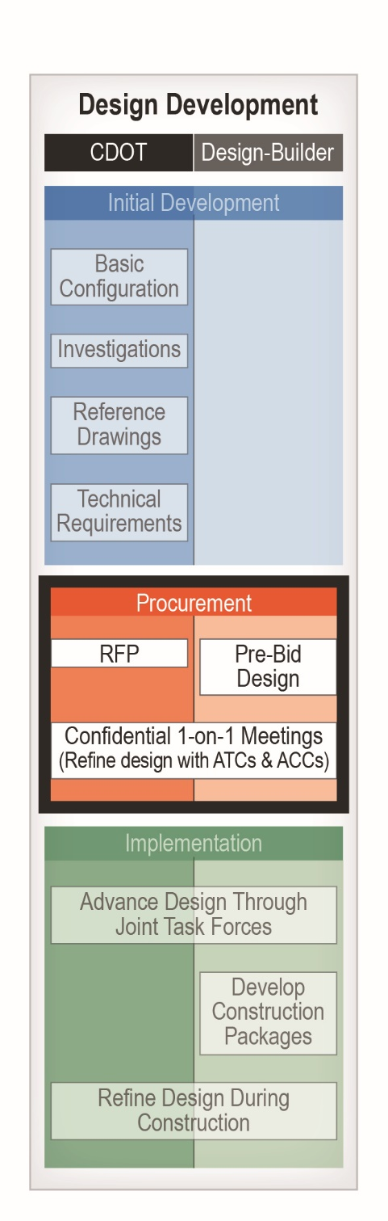
Federal guidelines state three to five firms should be short-listed and invited to submit Proposals. The Design Build Institute of America (DBIA) recommends short-listing three firms in “Principles of Best Value Selection.” Limiting the short list is important, recognizing the substantial level of effort that is required for Design-Build proposers to advance the design and prepare Design-Build Proposals. Limiting the short list strikes a balance between fostering competition and limiting the overall industry level of effort. The higher submitters perceive their probability of being selected, the more they are motivated to invest in their Proposals; this results in stronger best value Proposals from which the owner may select. Short-listing at least three firms provides the owner insurance so that if one firm withdraws, two firms remain to preserve a competitive selection process.
CDOT has established a best practice recommendation that three SOQ submitters be short-listed and invited to submit Design-Build Proposals.
CDOT reserves the right, at its sole discretion, to cancel the RFQ; issue a new RFQ; reject any or all SOQs; seek or obtain data from any source that has the potential to improve the understanding and evaluation of the responses to the RFQ; seek and receive clarifications to an SOQ; and waive any deficiencies, irregularities, or technicalities in considering and evaluating the SOQs. The RFQ does not commit CDOT to enter a contract or proceed with the procurement of the project. CDOT assumes no obligations, responsibilities, and liabilities, fiscal or otherwise, to reimburse all or part of the costs incurred by the parties responding to any RFQ. All such costs shall be borne solely by each proposer.

Phase 2—Request for Proposals, Pursuit Design, Proposals and Selection
Phase 2 of the procurement process for Design-Build delivery is initiated with the selection of the short-listed SOQ submitters that will be invited to submit a Design-Build Proposal for the project. Phase 2 includes a critical step in the project procurement: the submittal and evaluation of Proposals leading to the selection of the Design-Build contractor. However, most of the work performed in Phase 2 actually centers on the advancement of the design, both by the owner and the Design-Build proposers.
As shown in the highlighted section of Figure 5-6, during this stage of the project delivery, the owner advances the design through the development of the RFP Documents and the Reference Documents, including the Basic Configuration design, the Technical Requirements detailed in Book 2, and the contract defined in Book 1. The owner further advances the design through its continuing efforts in utilities and other third-party coordination and agreements and also advances permitting and environmental clearances. These efforts should be guided by risk mitigation and management considerations.
Figure 5-6. Design Development
Simultaneously, the Design-Build proposers perform their pre-bid (Proposal) designs to allow them to contractually bid and schedule the project. The Design-Build proposers typically also coordinate with third parties, to the extent allowed by the owner, to refine their designs and reduce their risks.
Together the owner and the Design-Build proposers collaboratively develop innovative design solutions to the project through the interactive ACC/ATC process to best meet the goals of the project.
The design development that occurs during the Phase 2 of the procurement process is where many of the advantages that Design-Build delivery can offer in terms of innovation, schedule, and price can be realized. The competitive nature of the procurement drives the innovation.

The Draft RFP and Industry Review
The RFP is usually issued in two steps, first as a Draft RFP and then as a final RFP. This two-step process allows the short-listed proposers to provide input into the development of the RFP through a process that is referred to as “industry review.” Proposer input into the development of the RFP can be beneficial in reducing project risks and improving best value. Proposers can identify Technical Requirements and contract clauses that are ambiguous or onerous and will result in risk pricing and/or potential claims. The owner then has the opportunity to revise the language to obtain stronger Proposals and minimize the potential for disputes. Changes to the RFP during industry review are global and go out to all proposers simultaneously. This is different than proposed changes as a result of the proprietary and confidential ACC/ATC processes that occur after the issuance of the final RFP.
When CDOT first started using Design-Build delivery, industry review was critical to the development of strong RFPs. Capitalizing on experience, CDOT has created RFPs that are more standardized and stronger documents, reducing the importance of the industry review. Nonetheless the industry review process still provides value in strengthening the RFP, getting contract buy-in from the proposers, and initiating and further developing relationships for the Phase 2 procurement. An industry review process should always be conducted, though the process can be streamlined on smaller projects.
The Draft RFP should be issued immediately or as soon as possible after the announcement of the short list. Short-listed proposers will want to start advancing their designs as rapidly as possible and are very limited in what they can do until the Draft RFP is issued. It is important to understand that the Draft RFP must be very near to its final completion for the industry review process to be effective. Ideally, the Draft RFP is in its final form excepting changes that respond to the industry review. In practice, there are inevitably portions of the Draft RFP that are not yet finalized and parts of the Draft RFP that are updated for the final RFP based on design progress, third-party coordination, and risk reduction activities. However, these revisions should be limited. If there is potential for substantial changes to the Draft RFP, then its issuance should be delayed until potential revisions are minimized.
The industry review process primarily consists of one-on-one meetings with each of the short-listed proposers to solicit input on the Draft RFP. The Draft RFP should be issued enough in advance of the industry review meetings to allow the proposers adequate time to review the document. One set of review meetings is usually adequate to solicit RFP input, although on large and complex projects additional meetings can be beneficial. There should be enough flexibility in the schedule to accommodate additional meetings if necessary. Proposers should be provided four hours of meeting time to ensure all of their concerns can be sufficiently discussed.
As with most one-on-one meetings, when the industry review meetings are conducted somewhat informally they are often more productive. Because CDOT’s primary role is to listen at these meetings, there is no need to maintain the same topics of discussion for each proposer. However, the project team should keep comprehensive notes of the meetings for internal use. The meetings are often more productive when proposers provide an agenda to the project team prior to the meetings. This provides the owner the opportunity to research issues in advance and to provide any necessary technical staffing at the meetings.
The CDOT team should initiate the meetings by discussing the ground rules for the meetings. The ground rules should be included in a handout so participants can be reminded of them throughout the meetings. Industry review meetings should include the following ground rules:
- The primary purpose of the industry review meeting is to develop a strong industry understanding of the RFP and to solicit industry input on the RFP.
- The meetings are informal to promote more interaction. The meetings are not formally documented.
- RFP comments received from one proposer may be shared with other proposers to assess the industry consensus on changes being considered. CDOT does not, however, divulge the names or identities of proposers providing review comments.
- Proposers are cautioned about discussions concerning Proposal ideas and ATCs; though CDOT makes reasonable efforts to maintain confidentiality, while the RFP has not been finalized, issues and topics discussed may not be considered proprietary and could be reflected in the final RFP.
Though the meetings are to solicit input from the proposers, the meetings should be initiated with a briefing from the CDOT team. Typical topics of the briefing are schedule, funding, third-party coordination updates, clearances, permitting, and ongoing investigations. For this part of the meeting, care should be exercised by the CDOT team to ensure that the same information is disseminated to all of the proposers.
A valuable topic to discuss at the industry review is the Proposal scoring format provided in the Draft RFP. As the Proposal scoring is the key to obtaining best value, it is important that it is clearly communicated and understood. Scoring discussions with proposers during the industry review can help the project team understand how the scoring is to be reflected in Proposals, which can lead to scoring improvements in the final RFP.
Proposers sometimes try to use the industry review meetings as opportunities to initiate discussions on Proposal ideas, ATCs, and ACCs. The project team should discourage such discussions as they are more appropriate to address during the one-on-one meetings held after issuance of the final RFP. In some instances, such as accelerated procurement schedules, ATC and ACC discussions are warranted. In those cases, it is important to clearly communicate to proposers that ATCs and ACCs discussed in advance of the issuance of the final RFP are at risk of being compromised by the language of the final RFP.

The Final RFP Process
The issuance of the final RFP indicates that the following has occurred:
- CDOT has obtained formal federal authorization.
- CDOT has allotted equal time to each short-listed proposer to discuss development of any changes that potentially could be included in the RFP (industry review meetings).
- Industry review comments have been reconciled and, if approved, included in the RFP.
- All changes that are included in the RFP have been reviewed for legal sufficiency.
- Typically, the decision document has been published.
- The project team members have identified the selection formula and evaluation plan they intend to use to determine best value, and the Instructions to Proposers (ITP) is finalized.
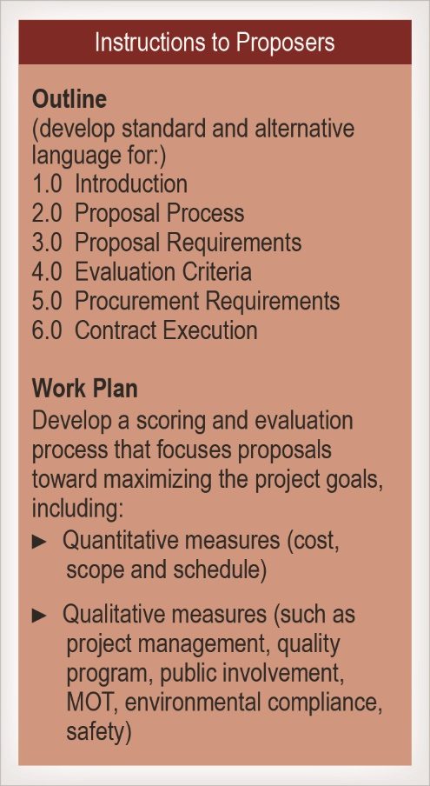
The final RFP process is more formalized than the Draft RFP process; industry comments and questions are addressed through the RFC process and additional changes to the RFP are made through the issuance of formal addendums. The release of the final RFP provides proposers with a high level of confidence in both the contract requirements and the selection criteria and process, allowing them to proceed with significant investments in both the design development and the Proposal development. At this point in the procurement process, proposers also develop ACCs and ATCs to propose to CDOT to provide best value benefits to the project.

Instructions to Proposers
The ITP provides guidance to the proposers on submittal requirements, procurement processes, and Proposal evaluation criteria. Most important, the ITP defines the ways the project goals will be optimized to provide the owner best value through a combination of cost, schedule, and technical considerations. The key elements of the ITP are summarized in Figure 5-7. A typical ITP and the source file ITP templates are available in the online Appendix on the CDOT Innovative Contracting web page or by contacting CDOT Innovative Contracting.
The ITP is initially released with the Draft RFP to allow industry review to provide commentary on the document prior to its finalization and release with the final RFP.
When the final ITP is issued as part of the final RFP, the ITP must be complete with only minor changes incorporated by subsequent addendums. The key elements of the ITP are discussed in the following sections.
Figure 5-7. ITP Elements

Evaluation Parameters
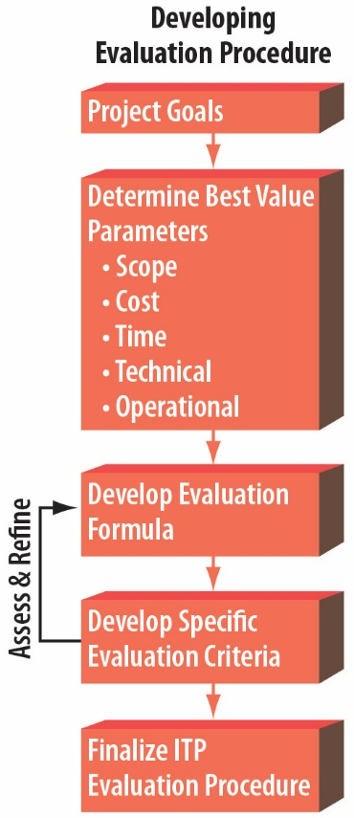
As the primary purpose of the ITP is to provide a process for the selection of the Design-Builder for the project, a logical first step in the development of the ITP is to identify the evaluation parameters and procedures that will be used for the selection. The evaluation parameters and procedures will then guide the development of the other elements of the ITP. Figure 5-8 illustrates the process. Design-Build delivery typically uses a best value selection methodology, which is generally defined as “a procurement process where price and qualitative factors are considered in the evaluation and selection process.” The project goals should be directly related to best value parameters, which typically include cost, time, scope, and technical design considerations and construction operational considerations (such as Maintenance of Traffic [MOT] and Public Involvement [PI]) parameters). For example, if a project goal is to minimize inconvenience to the traveling public, then a best value operational parameter could be the MOT approach and commitments, and a best value time parameter related to that goal could be commitments to minimize the duration of construction impacts. The best value parameters are then tied together with the Proposal price through a best value evaluation formula (algorithm). Each parameter is then assigned specific scoring criteria. Given the critical nature of the exercise, it is important that the evaluation procedure be tested against numerous scenarios through an iterative process to determine the parameters, formula, and criteria that best reflect the project goals.
Figure 5-8. Developing Evaluation Procedure

Design-Build Best Value Formulas
Best value formulas fall into the following categories:
- Low Bid (with a prerequisite of passing minimum Technical Requirements): Once CDOT determines which proposers meet the minimum technical criteria, the successful proposer is chosen objectively based solely on the lowest bid. This approach is used by CDOT only on small SDB projects.
- Price + Time (with a prerequisite of passing minimum Technical Requirements): This is a variation of the low bid approach that adds an objectively determined time element, similar to an A+B bid in a traditional Design-Bid-Build (D-B-B) delivery. This approach is most commonly used for CDOT SDB projects.
- Weighted Criteria: In this approach, best value parameters are determined and weighted by point values that reflect prioritized project goals. Each parameter is then scored, including the Proposal price and schedule components.
Often the technical parameters of the Proposal are qualitatively scored independently of the cost elements of the Proposal, which is referred to as a blind evaluation. After the technical scoring is completed, cost is independently scored by a quantitative formula and added to the other best value parameters to obtain the final score. This is the approach dictated by the Code of Colorado Regulations (2 CCR 601-15), and it is the approach that CDOT uses on most Design-Build projects.
Time elements of the Proposal can be either qualitatively scored or quantitatively scored by formulas.
- Qualitative Cost and Technical Score Trade-Off: This approach is similar to the Weighted Criteria approach, but rather than assigning scoring value to Proposal prices, the difference in Proposal prices is subjectively compared to the differences in the other best value parameters to assess whether or not a higher priced Proposal provides the best value due to the benefits the Proposal offers. This approach is not available to CDOT as it is specifically prohibited by the previously noted regulations.
- Fixed Price Best Proposal: This method sets a Guaranteed Maximum Price (GMP) and then allows proposers to vary the project technical approach and scope to fit within the GMP. The scope is typically varied through the use of Additional Requested Elements (AREs), which the proposer has the option of committing to. Each ARE is assigned point values in the ITP that reflect the value the owner places on the implementation of the ARE relative to the overall project. For example, a proposer may be able to obtain an additional three points in its overall score if the proposer commits to construct a bridge that was not included in the Basic Configuration. A weighted scoring criteria is then developed to assess the other best value parameters. When this method is used, care should be taken to estimate the GMP and the AREs accurately to ensure proposers are able submit Proposals at or below the GMP. Ideally, some proposers will be able to include some but not all the AREs in their Proposals at the price of the GMP. CDOT uses elements of this method.
CDOT standard practice for Design-Build delivery (except for SDB projects) is to use the Weighted Criteria approach with an independent quantitative calculation of the cost score. CDOT publically reveals the price proposal scores that are then added to the previously determined technical scores to obtain the publically announced determination of the apparent selection. This approach provides a very transparent process that ensures the Proposal price does not influence the technical scores.
The CDOT standard practice often allows for variable scope by including optional AREs along with a price proposal. The CDOT standard practice also uses a GMP, requiring that price to be equal to or less than a GMP (upset price) to ensure projects meet budgetary constraints.
Technical scores and price proposals are combined for the total evaluation score on CDOT Design-Build projects generally using one of the alternative algorithms in Table 5-1 on the following page.
There are many variations of these general formulas that may be applicable to specific projects, but for the most part the best value scoring formulas should stay close to these general methods to maintain a consistency of approach to which the industry can respond.
The determination of the exact algorithm to use should be focused on obtaining the best value in terms of achieving the goals of the project. The algorithm should be tested against numerous scenarios to ensure it provides the best value and to guard against unintended consequences.

Table 5-1. CDOT Design-Build Alternative Algorithms to Determine Total Evaluation Score
Alternative Algorithm | Formula | Result
Technical Score Adjusted by Price | Total Score = Ts x (GMP/Pp) | The highest score determines the apparent best value.
Proposal Price Score Adjusted by Technical Score | Total Score = Pp/Ts | The lowest score determines the apparent best value.
Qualitative Technical Score plus Quantitative Price Score | Total Score = Ts + (Pmax x Plow/Pp) | The highest score determines the apparent best value.
Qualitative Technical Score plus Quantitative Price Score (based on defined dollars per point) | Total Score = Ts + [Pmax – ((Pp – Plow)/($ per Pt))] | The highest score determines the apparent best value.
Note:
Ts = Technical Proposal score: the sum of all other best value scoring elements, including AREs
Pmax = Maximum Proposal price points
Pp = Proposal price
Plow = Lowest Proposal price
$ per Pt Factor = A defined dollar amount per point value
GMP = Guaranteed Maximum Price

Specific Criteria and Scoring
CDOT’s standard approach is to provide a maximum of 100 points for the total Proposal score, although the total points can be increased to provide more discretion in the scoring. The way those points are allocated between the various best value parameters should reflect the weighting of elements that best reflects the project goals. One key factor that is not usually captured in the project goals is the importance of price. The way in which price is quantitatively incorporated into the best value formula must be carefully considered to ensure the selection committee and the executive leadership is comfortable with potential outcomes that result in a proposer being selected with a price higher than the lowest Proposal price. For that reason, it is imperative that the CDOT team test the evaluation procedure against numerous scenarios.
Examples of best value parameters that can be assigned point values are shown in Table 5-2 on the following page.
Often the ITP identifies core CDOT values that are not project-specific goals but are nonetheless important to the success of the project and are therefore scored. Quality and safety are examples of CDOT core values.
Qualitative best value parameters that are determined to be part of the evaluation procedure are further elaborated upon in the ITP to provide more specific direction to the proposers on the important aspects of each parameter.

Table 5-2. Relating Project Goals and Values to Best Value Scoring Parameters
Project Goals | Possible Best Value Parameters
Maximize operational capacity | - Project technical approach and commitments  - AREs
Maximize use of available funds | - AREs  - Additional Proposal scope commitments
Manage impacts during construction, or  Minimize inconvenience to the traveling public, or Minimize inconvenience to the stakeholders | - MOT approach and commitments  - PI approach and commitments  - Time of completion  - Duration of construction impacts
Complete the project on or before a set date | - Time of completion  - Time to obtain key schedule milestones
Provide a high-quality project | - Quality Management Plan approach and commitments  - Technical approach and commitments
Safety of the public and workers | - Safety Management Plan approach and commitments
Maximize project durability or  Minimize life cycle costs of project | - Maintenance Level of Service commitments  - Low-maintenance structures  - Low-maintenance pavement  - Other low-maintenance designs

The time-related parameters can be assessed either qualitatively or quantitatively. An example of a quantitative formula for schedule is:
Schedule Score = Max Points × (lowest proposed duration/proposer’s duration)
There many other ways to quantitatively score time. Though schedule is often assessed with a formula, it is not uncommon to score time-related items subjectively, with other qualitative technical elements.

Additional Requested Elements
Sometimes, CDOT incorporates AREs into the best value in order to maximize the project scope. AREs are specific, well-defined, and often prioritized additions to the Basic Configuration that the proposer can optionally decide to include in its Proposal. Each ARE has a defined point value that typically is provided in its entirety to the proposer. However, there have been some innovative past uses of variable scope AREs that are in turn variably scored. Variable scope AREs allow the proposers to more closely match the GMP to the project scope of work.
Proposers should be required to include all AREs before being allowed to provide a Proposal price less than the GMP. Under no circumstance should the proposer be allowed to provide a Proposal price higher than the GMP that includes AREs.
As AREs represent additional costs to the contractor, the relationship between ARE scoring and the price scoring formula should be carefully considered. Points assigned to the AREs should be weighted in such a way that the proposer is incentivized to include the AREs in the Proposal.
Proposers can be allowed the option of including or excluding any or all AREs if they feel that would give them the best opportunity to provide the best value to the owner. Or, proposer’s can be directed to include AREs in an order of priority defined by the owner. However, the more flexibility the proposers are given to select which AREs to include in their Proposals, the more opportunity they have to include those AREs that best match their designs, construction methods, and means, which generally provides better project value. AREs also can be indirectly prioritized by the CDOT team by providing more points per dollar for the more important AREs.
AREs do not always fall within the umbrella of the NEPA decision document governing the project. In those cases, the proposers need to be informed of their responsibilities related to obtaining the necessary environmental clearances for the ARE.

Guaranteed Maximum Price
CDOT uses a GMP to control the maximum Proposal price and meet the budgetary constraints of the project. The ITP will state:
“If one or more Proposals are submitted with a Proposer Price equal or less than the Guaranteed Maximum Price (GMP) and a Technical Proposal score of Good or better, CDOT intends to award the Project according to the scoring methods outlined in the ITP, without consideration of Proposals that have Proposer Price above the GMP.”
This puts strong pressure on the proposers to submit Proposal prices at or below the GMP. However, the use of a GMP requires that CDOT provide a Basic Configuration with a high probability that contractors are able construct at or below the GMP price. This requires that the CDOT team develop a reliable construction cost estimate even though the level of the design of the project is typically less than 30 percent. In some cases, the design of certain high-risk elements may need to be further advanced to reduce cost-estimate risk; this approach should be used sparingly because it is basically duplicates the efforts of the proposers.
The use of AREs can significantly reduce the risk of Proposal prices exceeding the GMP. Their use allows the GMP to be set so there is strong certainty that the Basic Configuration can be obtained at a price less than the GMP. AREs can then be used to give the proposers an opportunity to increase the project scope and price up to the level of the GMP. The use of probabilistic estimating procedures can be beneficial in identifying ARE cost ranges. The project cost should have a very high probability of being within the GMP without any AREs, with a commensurately low probability of being within the GMP if all the AREs are included.
Because of the critical nature of properly setting the GMP, CDOT has adopted a best practice of obtaining a construction cost estimate from an Independent Cost Estimator (ICE) to verify the project team’s cost estimate. ICE firms perform production-level cost estimates using the same procedures that contractors employ in bidding projects. The methodology can provide a significant improvement in the level of confidence in the accuracy of the cost estimate.

Evaluation Plan
A formal evaluation plan must be developed, documented, and approved by the EOC. The evaluation plan provides a detailed approach to the Proposal evaluation process including the selection team, advisors and assistants, specific scoring processes and worksheets, meeting schedules, and security and confidentiality procedures. Evaluation of SOQs and Proposals for a Design-Build procurement is discussed in detail in Chapter 6 of this manual.

Structure of the Proposal
The ITP defines the structure of the Proposals, which should generally comply with the following format:
Volume I Executive Summary (up to 15 pages)
Volume II Proposer Information and Certifications (using forms provided in the ITP) and price proposal (Form J)
Volume III Technical Proposal (up to 100 pages)
Volume IV Project Plans, ARE(s), ATCs, and Schedule
Page limits should be set for Volume I and Volume III. Volume IV, which include the project plans, does not typically have a page limit. The purpose of the executive summary in Volume I is twofold: (1) to provide the evaluation team with a summary of the Proposal and (2) to provide the EOC and stakeholders a summary of the contractor’s conception of and approach to the project and the means by which the contractor meets or exceeds the project goals.
The price proposal is provided in a separately sealed Volume II that is provided independently to the Price Evaluation Team (PET). The PET provides a review of the competency of all the legal, bonding, and miscellaneous forms and certificates required for a responsive submittal. The PET also opens the sealed proposers’ price proposals and reviews the competency of the pricing, after completion of the technical evaluations, in accordance with Colorado Design-Build regulations (2 CCR 601-15 § 11). The PET must be completely independent of the technical review team.
To both eliminate the need to review Proposals that exceed the GMP and comply with the Colorado Design-Build regulations, the ITP can require proposers to provide a separately sealed certification of whether or not their Proposal price is within the GMP without revealing the actual price.
The amount of information required from submitters and the page limits and organization of the Proposal should be well thought out and clearly communicated to the proposers. Overly extensive Proposals are a burden to both the proposers and reviewers, often provide limited additional value, and can overload the reviewers with insignificant information that distracts from the truly important aspects of the Proposal.

Alternative Configuration Concept / Alternative Technical Concept Process
ACCs and ATCs form the backbone of the innovation process in Design-Build delivery. They are confidential and proprietary changes to the contract requirements that are approved by CDOT for a specific proposer based on the owner’s determination that the ACC/ATC provides a product that is equal to or better than the corresponding Basic Configuration or the Technical Requirements. ACCs change the Basic Configuration that is defined in Book 2, Section 1 (General) of the Technical Requirements. ATCs are concepts that propose changes to all subsequent sections of Book 2 – Technical Requirements. CDOT can, however, identify certain sections or parts of sections that are specifically excluded from consideration of ATCs through the ITP.
Because ACCs can change the Basic Configuration of the project, approval of ACCs are typically required from the EOC. ATCs are typically approved by the Project Director or the Project Leadership Team (PLT) to facilitate an expeditious process, which is critical for an effective ATC process.
Proposers are willing to expend considerable effort to identify and develop ACCs and ATCs that provide equal or better products for less cost in order to gain an advantage over competitors as they vie to be the winning team. The most impactful ACCs/ATCs actually provide a better product for less cost. Often the proposer that is most successful in the ACC/ATC process wins the project.
The ACC/ATC process is a collaborative effort for both the owner’s team and proposer’s team. They are in essence working together to advance the project design in a manner that provides the most cost-efficient project that meets and exceeds the project goals. Owners’ teams that embrace the collaborative process obtain the most value for their projects.
Confidential one-on-one meetings provide the venue for the ACC/ATC collaboration. A minimum of two four-hour confidential one-on-one meetings should be offered to each proposer, and if possible there should be available time in the schedule to add more meetings as they are often beneficial to the process. The extent of one-on-one meetings should be tailored to the project; more complicated projects should have longer procurement periods and additional ACC/ATC meetings.
Confidentiality must be strictly maintained, and to that end the CDOT team should consist of a core group from the PLT that has decision-making authority and can provide a strong basic understanding of the project and the RFP. The core group is then supplemented by technical experts as necessary to address the specific topics of the meeting.
Proposers should be encouraged to provide agendas in advance of the meetings to allow the CDOT team to familiarize themselves with the topics and provide any necessary technical expertise at the meeting. To maintain security and confidentiality, no physical documentation or electronic files should be taken from the meeting.
The CDOT team should strive to provide strong, reliable direction to the proposer teams at the meetings. ACCs and ATCs can have significant impact on the proposers’ designs, which are being rapidly advanced throughout this phase of the procurement. If proposers have to wait for formal responses to formal submittals to understand CDOT’s position on their ACCs/ATCs, their design development process can be severely limited. When CDOT provides reliable feedback at the meetings, the contractor has greater opportunities to refine ACCs and ATCs and obtain CDOT approvals. It is important for both parties to recognize that only ACCs and ATCs that have received written approval can be included in a Proposal.
To support the real-time decision making, the CDOT team should make use of time-outs during which the CDOT team can confidentially discuss the proposer’s concepts and develop responses. It is not always possible to provide decisive responses to ACCs and ATCs at the meeting. In those instances, it is more effective to schedule subsequent meetings rather than require the proposer to formally submit an ACC/ATC without knowing the likely outcome. When a proposer has to submit the formal ACC/ATC without knowing the likely outcome, it results in a costly need for the proposer to advance the design and Proposal preparation on two potential outcomes, and it does not contribute to efficient solutions to the challenges of the project. Any additional meetings must be offered equally to all proposers.
The CDOT team should designate a note taker to keep comprehensive notes of the meeting for CDOT’s records. To maintain confidentiality, formal minutes of the meetings are not distributed to the attendants. Therefore, it is important for CDOT to have a clear internal record of the discussions.
ACC and ATC discussions should not include cost discussions because cost savings should not be relevant to CDOTs “equal or better” decisions. Approval logic should never be based on the idea that the ATC is equal or better because the money saved by using the ATC can be applied to other elements of the project. ACCs and ATCs should not be considered as opportunities to negotiate price and scope; in all cases they must provide an equal or better product relative to the Basic Configuration, AREs, and the Technical Requirements.
ACCs and ATCs do not always fall within the umbrella of the NEPA decision document governing the project. In those cases, the proposers need to be informed of their responsibilities related to obtaining the necessary environmental clearances for the ACC/ATC.

Requests for Clarification and Addendums
In the ITP, a process for proposers to formally submit RFCs, via email and signed letters, throughout the final RFP procurement process must be provided. CDOT then posts responses to RFCs on the project website, without revealing the names of the submitters. It is most effective to maintain a continuous process of responding to RFCs as quickly after their receipt as possible. Ideally, CDOT responds to all RFCs. An expeditious approach is to post all RFCs shortly after they are received, provide prompt responses to the RFCs that can be quickly answered, and identify the other RFCs as “response pending.” RFCs do not need to be posted as addendums as they are clarifications and not revisions to the RFP.
Project directors are discouraged from having informal discussions with the proposers outside of the one-on-one meeting process, as such action can potentially compromise a fair and impartial selection process and expose the procurement to more risk of a protest.
After the issuance of the final RFP, all further modifications to the RFP must be implemented through formal addendums. Formal addendums need approval from the Federal Highway Administration (FHWA) prior to inclusion into the final RFP. On large and complex Design-Build projects, addendums are inevitable. Addendums that involve important changes to the contract requirements should be issued promptly and without waiting to accumulate addendum revisions. Issuance of relatively minor addendums can usually wait, but contractors should be notified of CDOT’s intent to formally issue the addendum as soon as practicable. When addendums are required due to RFCs, a beneficial approach is to respond to the RFCs by informing proposers of specific changes that will be in future addendums, thereby maximizing the time proposers have to respond to the addendum.
When addendums are issued, a track changes type of format can be used to assist the proposers in identifying the changes to the RFP. Track changes can be included directly in the addendum pdf, or in a supplemental Word file for informational purposes only.
Addendums must not compromise confidential ACCs and ATCs presented by proposers. After the issuance of the final RFP, innovation proposed by proposers is owned proprietarily by the proposers and must not be shared with their competitors through an addendum. The exception to this rule is when a proposed ATC or ACC takes advantage of an error or inconsistency in the RFP that should be corrected by an addendum.

Document Control and Data Management
All four books of the RFP and the ITP and the supporting Reference Documents result in a large amount of time-sensitive data that must be made available to the proposers. Because the design development is continually advanced during the procurement phase, the data must be frequently updated throughout the procurement. Expeditious data updates benefit the project by allowing proposers’ designs and Proposals to be more responsive to the project conditions. CDOT maintains the project data through the CDOT project website. In some cases, a third-party project-specific database is maintained (sometimes provided by CDOT’s project consultant).
However the data is provided, it must be easily accessible and efficient for both downloading and updating of information. Formal addendums with notifications to proposers must be used for formal contract modifications. However, supporting information and informal changes to documentation should be continually provided to the proposers as it becomes available. The volume of information might make it very difficult for proposers to understand what information has been added or modified without being notified by CDOT. An efficient approach to the problem is to maintain a data log. The data log provides a chronological listing of information that is posted or revised on the website. It is easy for the proposers to periodically check the data log to identify when new information has been posted.

Public Opening
To ensure transparency and build continued trust with the industry, CDOT publically discloses each proposer’s technical Proposal score, Proposal price (for those prices that are at or below the GMP), and total score. The disclosure is made during CDOT’s standard bid opening process, where the proposer with the highest best value score is announced as the "Apparent Selected Proposer.”
Proposal prices that are over the GMP should be withheld at the bid opening to preserve the potential for a Best and Final Offer process, as is discussed in the following section.
The qualitative scoring is completed and approved by the EOC prior to the bid opening, allowing the Proposal prices to be incorporated into the scoring and the total score to be announced at the public bid opening. It is important to note that the Colorado Design-Build regulations require that the qualitative scoring be completed prior to opening the price proposals (2 CCR 601-15, Section 11, Part B, item No. 8).

Best and Final Offers
CDOT reserves the right to enter into a Best and Final Offer (BAFO) process with the proposers if all of the Proposal prices exceed the GMP. The BAFO process allows the Project Director to enter into discussions with the proposers, make revisions to the RFP, and solicit revised technical and price proposals with the goal of obtaining lower Proposal prices that meet the GMP. It is important to recognize that that BAFO process represents the last opportunity for the owner to award the project when the defined procurement process does not result in an acceptable Proposal. The BAFO process should not be considered a standard of practice to be used to negotiate the project scope and price.
The BAFO process typically includes:
- formal discussions with proposers;
- notice that the BAFO process is the opportunity to submit a BAFO;
- notice of a common cut-off date and time that allows a reasonable opportunity for submission of written BAFOs; and
- notice that if any modification is submitted, it shall be received by the date and time specified and is subject to the late submissions, modifications, and withdrawals of Proposals provisions of the ITP.
The BAFO process typically is not necessary provided there is one competent Proposal with a price at or below the GMP. But when a BAFO is necessary, the Colorado Design-Build regulations (2 CCR 601-15, Section 13) require that Proposal prices be kept confidential in order to avoid the use of “auction techniques” in the BAFO process. For this reason, if there are any Proposal prices that are over the GMP during the bid opening, they should be kept confidential until such a time as it is determined that a BAFO will not be necessary for the project.
After receipt of the BAFOs, CDOT does not reopen formal discussions and the BAFO becomes the basis for any award. BAFOs are evaluated as stated in the ITP based on the consideration of the revised technical and price proposals.

Stipends
CDOT typically provides stipends to unsuccessful but responsive proposers. The stipend provides a partial reimbursement to the proposers for their efforts in advancing the project design and preparing their Proposals. Stipends should be provided in the range of 0.05 percent to 0.15 percent of the GMP or the anticipated bid cost. Though the amount is generally much less than the investments by the proposers, it is still a valuable reimbursement commitment from the owner. In return for the stipend, CDOT is entitled to use any and all concepts, ideas, ATCs, and information contained in the Proposals without limitation. Each proposer acknowledges this CDOT right. However, proposers may refuse the stipend if they desire to maintain the ownership of all of the information in their Proposals.
CDOT provides the successful proposer with all the ATCs and ACCs of the unsuccessful proposers who accepted stipends as soon as practicable for incorporation as a Value Engineering Change Proposal (VECP) at the discretion of the proposer. The unsuccessful proposers are relieved of any responsibility and liability for any of their concepts and designs that are used for the project.

Protest Procedures
Losing proposers are entitled to protest the selection as set forth in the Design-Build regulations 2 CCR 601-15 § 22 and in C.R.S. §§ 24-109-101-404. The procedures provide, among other things, that the CDOT Chief Engineer or his designee is authorized to settle and resolve any protest within seven working days after the protest is filed. The decision shall inform the protesters of their right to appeal administratively or judicially in accordance with C.R.S. §§ 24-109-201-206. The decision is subject to appeal to the executive director of CDOT.
Protests may be made regarding CDOT's approval of changes in a proposer's organization or decisions regarding responsiveness, best value evaluation rankings, or Award of the Contract. Protests must be filed by hand delivery to the CDOT Project Manager within seven working days of being informed by CDOT of the decision being protested. The protester shall concurrently file a Notice of Protest with the other proposers. The Notice of Protest shall state the grounds of the protest.
If a Notice of Protest is filed, CDOT may proceed with the procurement. However, CDOT shall not Award the Contract until the protest is withdrawn or decided.
If the protest is denied, the firm filing the protest shall be liable for CDOT’s costs reasonably incurred in defending against the protest, including consultant fees and all unavoidable damages sustained by CDOT as a consequence of the protest. If the protest is granted, CDOT shall be liable for payment of the protesting firm’s reasonable costs, as defined in 2 CCR 601-15 § 22, No. 3.

Design-Build Delivery Interface with Other Processes
Design-Build delivery is unique in the way in which it interfaces with many processes that are integral parts of CDOT transportation projects. Primary among those are FHWA processes, environmental processes, and CDOT internal administrative processes. This section identifies key elements of interfaces between those three processes and Design-Build delivery, primarily through the use of flowcharts.

Environmental Processes
Design-Build delivery interface with environmental processes through the procurement phase is shown in Figure 5-9. As the figure illustrates, environmental interface is important throughout the development and execution of Design-Build delivery. Most all significant transportation projects include elements of risk associated with the environmental conditions. As a result, environmental conditions play a role in the selection of the appropriate method of delivery, the initial project development, the development of the RFP, the procurement process, and ultimately the implementation of the project. In fact, if environmental risks, such as compliance or schedule, are not carefully managed in Design-Build delivery, the potential for negative consequences can be greater than in traditional D-B-B.
Federal regulations establish the parameters by which state transportation departments may deliver projects using Design-Build (23 CFR Part 636). The environmental aspects of the regulation are stated in Chapter 1 of this manual. Key environmental elements of the regulation are:
- Design-Build procurements may proceed to award prior to the conclusion of the NEPA process and obtaining a decision document.
- Design-Build may proceed with the preliminary design after the award provided certain conditions are met to maintain the integrity of the NEPA process when not yet completed.
- FHWA approval is necessary prior to issuing the RFP, awarding the project, and proceeding with the preliminary design in projects where the NEPA process is not complete.
Per guidance from FHWA, CDOT has established a standard of practice that prohibits the issuance of a final RFP on Design-Build projects until the NEPA process has been completed and a decision document has been signed. Exceptions to this practice should be carefully considered and must obtain CDOT executive approval, which would generally be obtained through the project EOC.
If the NEPA process has not been completed prior to the issuance of an SOQ or an RFP, the solicitation document must include a statement of the status of the NEPA process and a statement that the procurement process and preliminary design are consistent with the NEPA requirements and mitigations and do not preclude any of the NEPA alternatives currently under consideration. FHWA should concur with this approach.
When a specific Design-Build project is developed within the limits of a previously completed NEPA decision document, it is not uncommon for the design development of the project to vary somewhat from the preferred alternative of the NEPA decision document. In those instances, it may be determined that a formal environmental reevaluation is required to be completed prior to the issuance of the final RFP in order to determine the requirements for the final NEPA approvals. When an environmental reevaluation is necessary, its processes must be carefully determined and integrated into the design development procurement schedule for the project as it can often dictate the critical path of the project schedule.
It is not uncommon for Design-Builders to develop designs that are not fully consistent with the final NEPA decision documents, usually as a result of ACCs and ATCs. In those cases, the responsibility and risk for obtaining a revised environmental clearance is typically allocated to the Design-Builder through conditional approval of the ACCs and ATCs.
In situations where the NEPA process had not been completed prior to the Design-Builder starting work, the Designer Builder’s specific responsibilities concerning NEPA approvals and associated environmental permitting processes must be clearly defined in the RFP and Contract Documents. The process requires the Design-Builder to closely coordinate with both CDOT and FHWA.
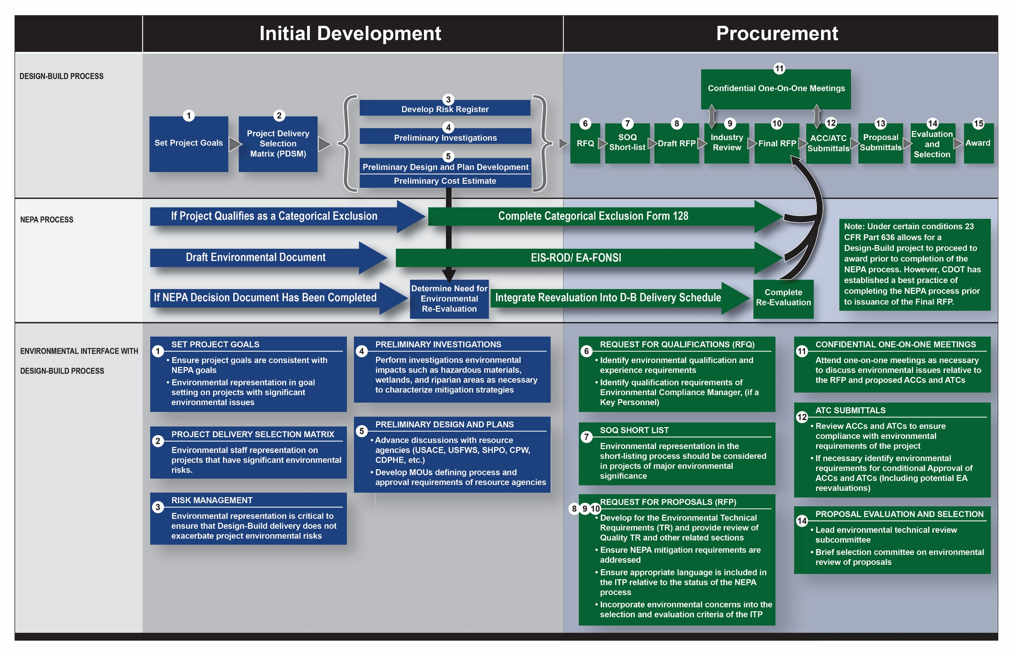
Figure 5-9. Environmental Interface with Design-Build Process

FHWA Processes
As most CDOT projects include federal funding, the interface with Design-Build projects and the FHWA is an important component of the delivery method. CDOT and FHWA have jointly developed the Colorado Department of Transportation Federal-Aid Highway Program Stewardship and Oversight Agreement, which defines how they will work together to provide project and program oversight.
The stewardship agreement stipulates that Design-Build projects that require coordination between CDOT and FHWA must determine the FHWA level of project oversight. The Colorado Division of FHWA determines whether a project is a Project of Division Interest (PoDI). If the project is determined to be a PoDI, FHWA and CDOT jointly develop a project-specific document titled “Oversight Roles and Responsibilities.” The document should typically address the following areas of coordination:
- FHWA involvement in the project organization, including the EOC, the Project Management Team (PMT), PLT, and Project Technical Teams (PTTs)
- FHWA review and approval of procurement activities, including the RFQ, SOQ, and short-listing; the Draft RFP; the final RFP; RFP addendums; ACCs and ATCs; and Proposals and Proposal evaluations
- FHWA approvals of Findings in the Public Interest (FIPIs) for proprietary items
- FHWA project approval (obligation authorization) prior to release of the final RFP
- FHWA formal concurrence of the Award
- FHWA approval of design exceptions
- FHWA approval of an Interstate Access Request, if applicable
- FHWA approval of NEPA decision documents, and reevaluation if applicable
- FHWA review and approval of certain defined plan submittals prior to release for construction
- FHWA review and approval of major change orders
- FHWA involvement in project Acceptance
- FHWA involvement in Final Voucher and Closure
An example Oversight Roles and Responsibilities document is provided in the online Appendix on the CDOT Innovative Contracting web page or by contacting CDOT Innovative Contracting.
A key role of FHWA is to ensure that NEPA processes are appropriately completed and approved for the project. Section 5.4.1 discusses the Design-Build interface with environmental clearances.
Many Design-Build projects include improvements to federal interstate highways, which usually require Interstate Access Requests (IARs). IARs must follow a prescriptive FHWA process and are often a subject to FHWA approvals beyond the authority of the local Colorado Division. The CDOT project team should closely coordinate the development of IARs with FHWA to accomplish their timely completion. A detailed process schedule should be developed and integrated into the Design-Build procurement schedule to ensure appropriate time is allocated for the process. The FHWA typically requires the completion of NEPA decision documents prior to IAR signature.
Section 10.4.4, titled “Major Projects,” of the stewardship agreement discusses the FHWA requirements for Major Projects. A Major Project is a project with an estimated total cost exceeding $500 million with a high level of interest by the public, Congress, or the Administration. Major Projects require a high level of FHWA and CDOT emphasis, including the following activities:
- Cost Estimate Reviews (CERs): Including an independent cost estimate. Information on cost estimating is available on the FHWA Innovative Program Delivery website:
http://www.fhwa.dot.gov/ipd/project_delivery/tools_programs/cost_estimating.

- Project Management Plan (PMP): This document should clearly define the roles responsibilities, processes, and activities necessary to manage the project. Information on the PMP is available on the FHWA Innovative Program Delivery website:
http://www.fhwa.dot.gov/ipd/project_delivery/tools_programs/project_management_plans.

- Finance Plan (FP): The FP must be completed and submitted to FHWA for review and approval with sufficient time to obtain approval before starting construction. Information on the FP is available on the FHWA Innovative Program Delivery website:
http://www.fhwa.dot.gov/ipd/project_delivery/tools_programs/financial_plans.
The Design-Build interface with FHWA processes through the procurement phase is illustrated graphically in Figure 5-10. FHWA Design-Build processes for Major Projects are shown in Figure 5-11.

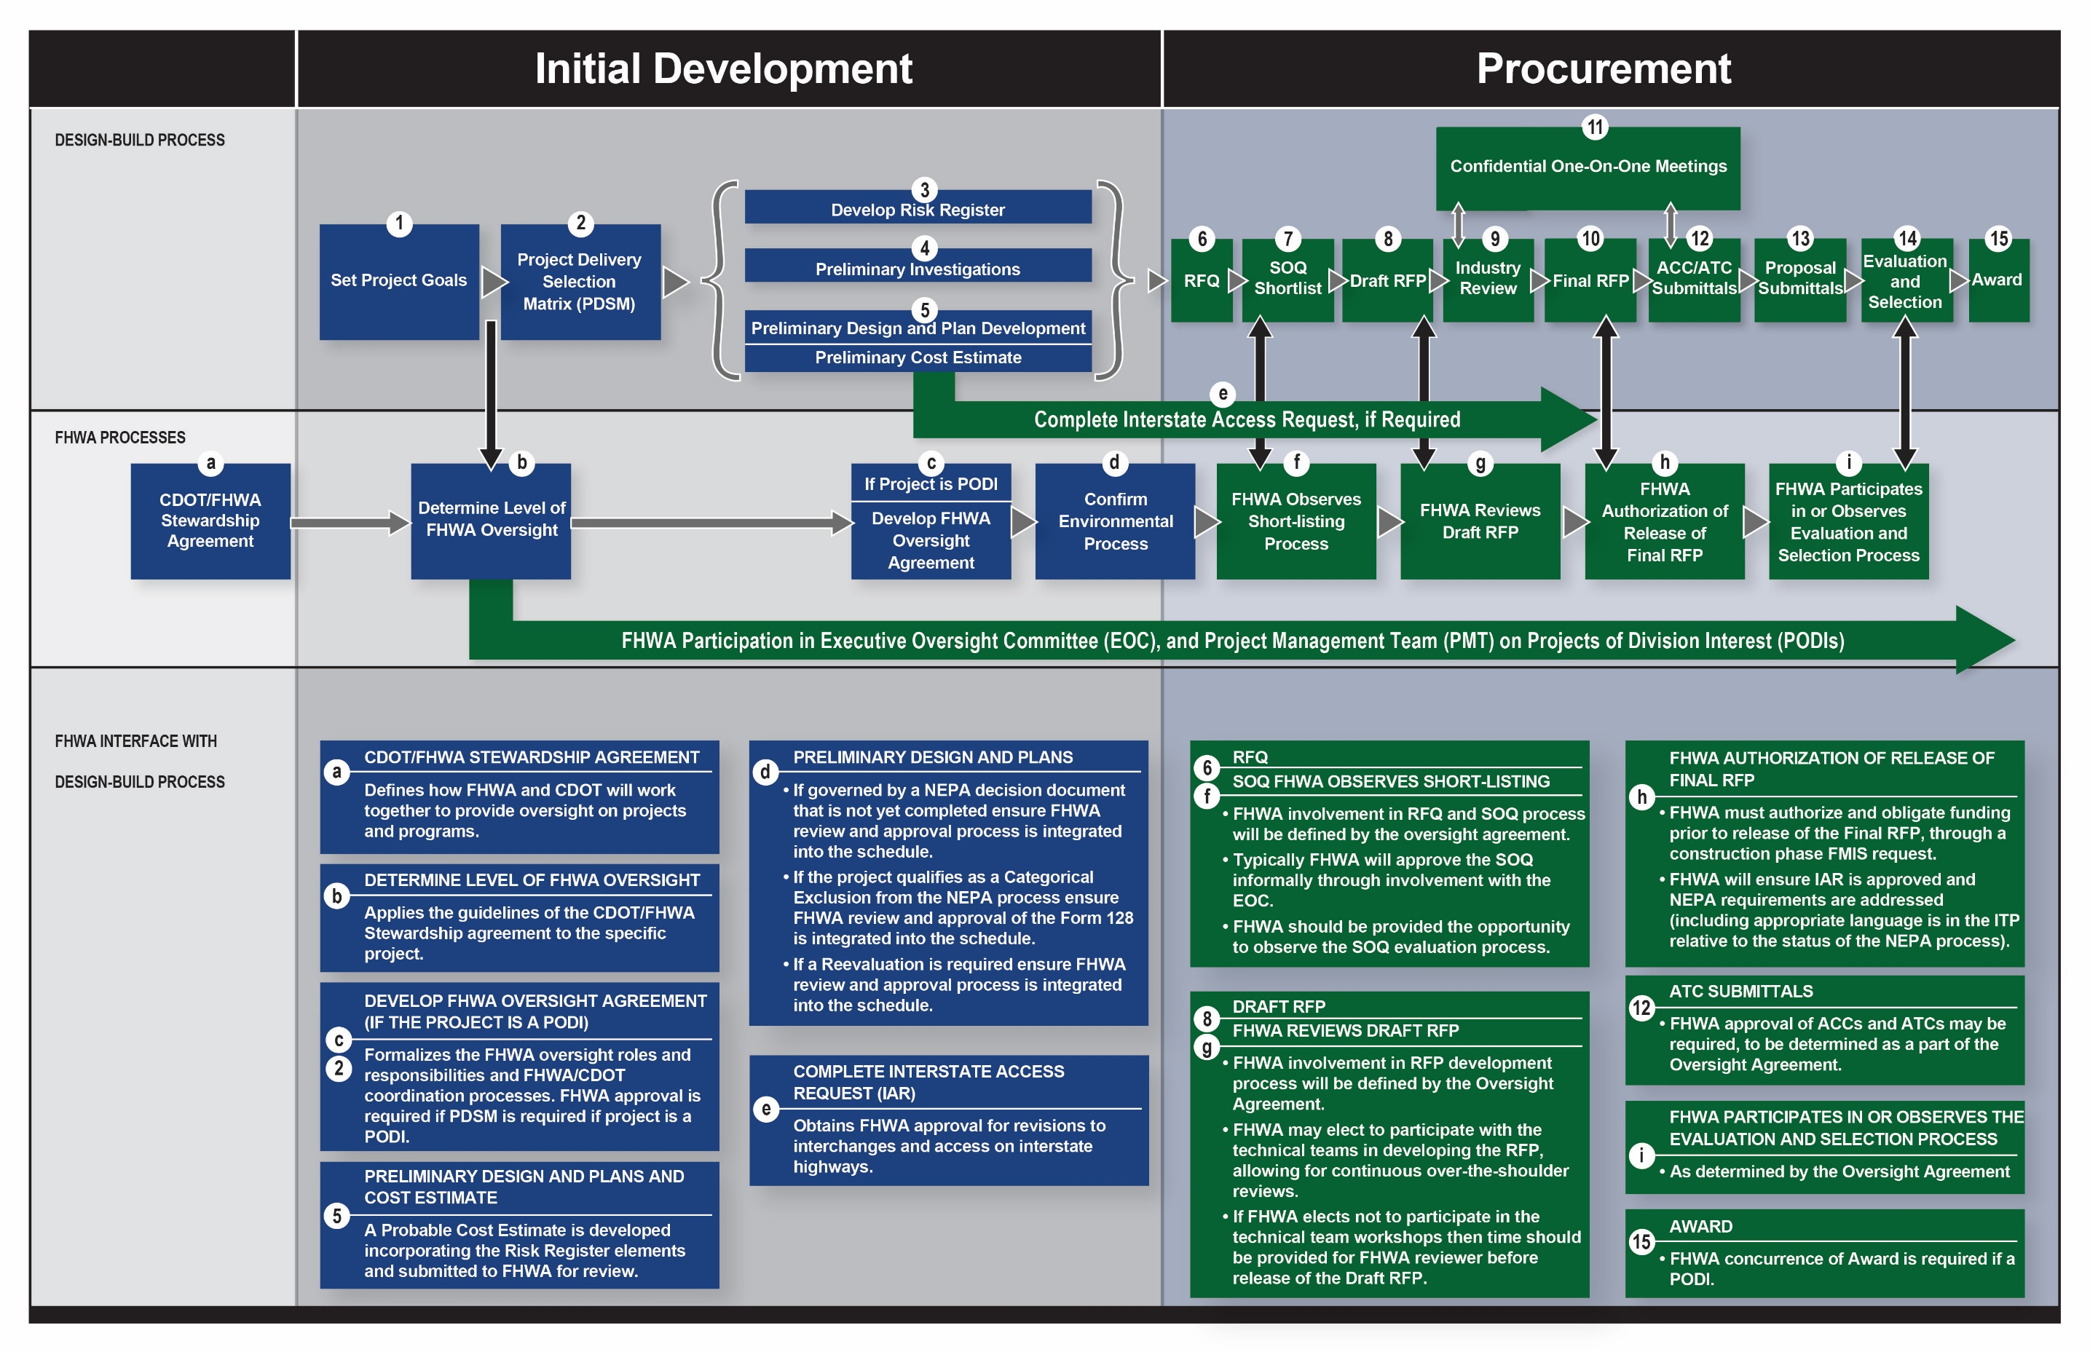
Figure 5-10. FHWA Interface with Design-Build Process

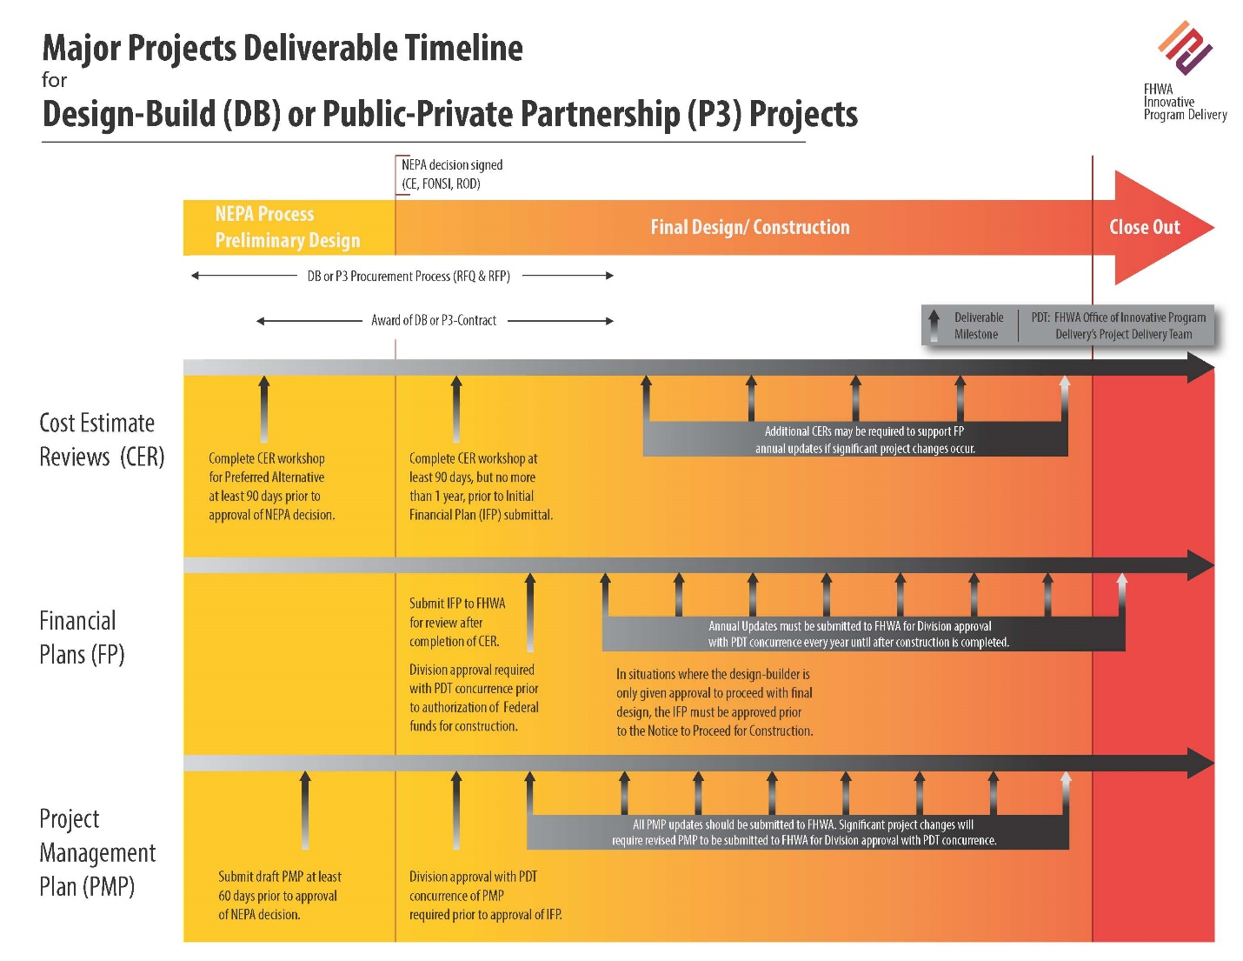
Figure 5-11. FHWA Design-Build Processes for Major Projects

Design-Build Institute of America, “DBIA Position Statement: Principles of Best Value Selection” (2012), 2, retrieved from https://www.dbia.org/resource-center/Documents/ps_bestvalue.pdf.
American Association of State Highway and Transportation Officials, AASHTO Guide for Design-Build Procurement 2008 (Washington, DC: AASHTO, 2008), 3.
Federal Highway Administration Colorado Division and the Colorado Department of Transportation, Colorado Department of Transportation Federal-Aid Highway Program Stewardship and Oversight Agreement (March 2015), retrieved from https://www.codot.gov/business/designsupport/cdot-fhwa-stewardship-agreement/final-stewardship-agreement.

